**Create partition on newly attached disk as per below instructions –**

Launch virtual machine in the cloud , attach 20 GB EBS volume

1. Create 2 primary partitions of 3 GB each  
    b) Create 2 logical partitions of 6 GB each  
    c)  Format all 4 partitions and create ext4 filesystem on that  
    d) Create 4 folders inside root ( / ) folder name it as Data1, Data2, Data3, Data4  
    e) Mount all formated partitions on the respective folders  
    f)  Create empty file inside each folders of size 2 GB, 2GB, 4 GB and 4 GB respectively  using  command -  dd - "convert and copy a file"  
    g) Go inside /Data1  and run  command -  while(true); do sleep 5s; done  , do ctrl-z  
    h) Check disk utilization of each mount point  
    i)  Unmount all partitions /Data1, /Data2, /Data3 and /Data4

**Ans:**

* Attached a 20 GB EBS volume to the EC2 instance.

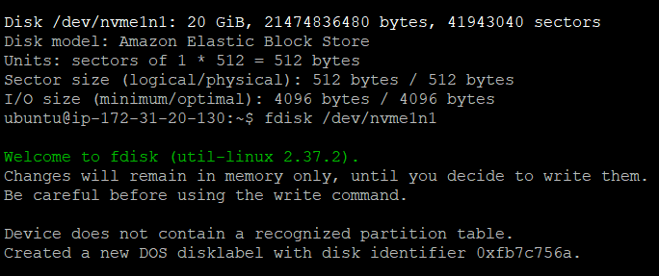

* To create partitions in the following disk used **fdisk** the command to go inside it.



* To create a new partition 🡪 pressed “n”
* To create a primary partition 🡪 pressed “p”
* Kept the partition number and first sector as default 🡪 pressed <Enter>
* In last sector gave “+3G” which means setting 3GB as the 1st primary partition.

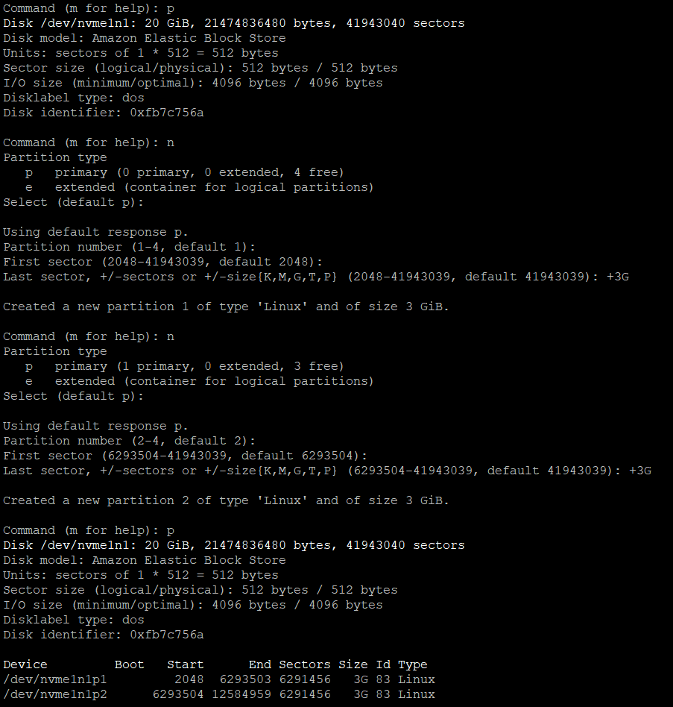

* Used the command “w” to save the changes.

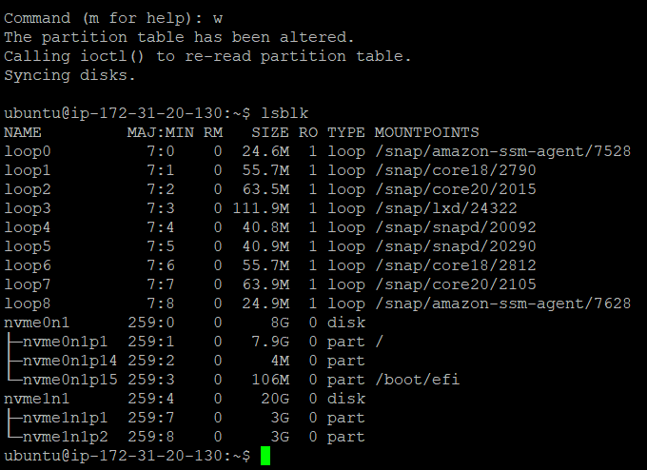

* To create logical partitions, 1st of all set the rest of disk space as Extended partition.

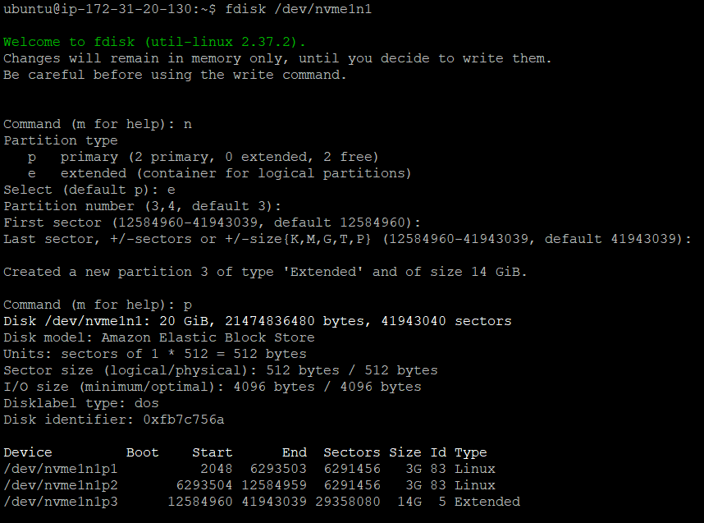

* After creating the extended partition. When we go for new partition its automatically redirect us for the logical partition.
* Set two logical partitions of 6GB each.
* To check the **newly created partition table** 🡪 pressed “p”

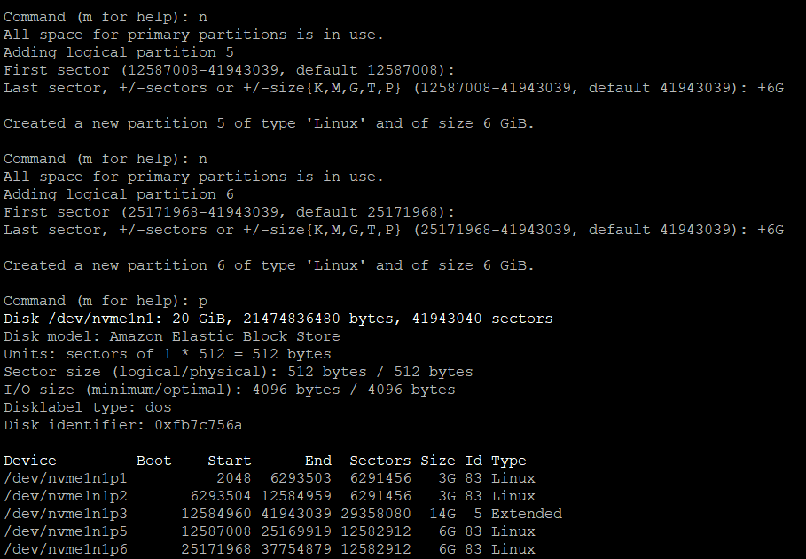

* Used the **partprobe** command to inform the O.S. of partition table changes.
* **lsblk** command to show the list of blocks.

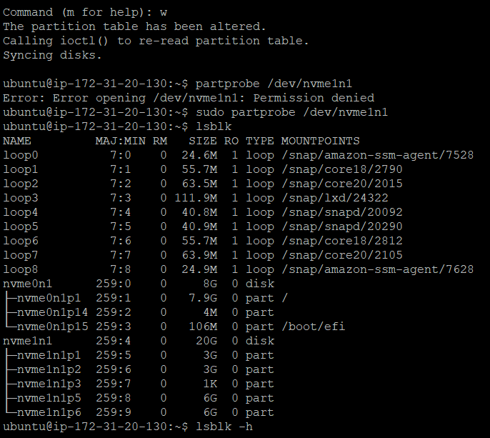

* To re-check the newly created partitions.

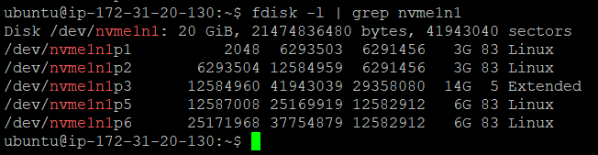

* Formatting all 4 partitions and creating **ext4** filesystem on that by using **mkfs** command which means make file system.

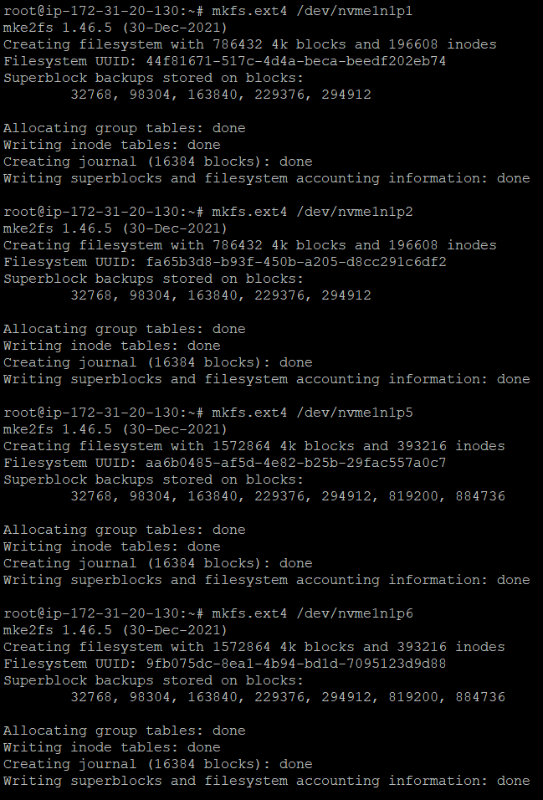

* Creating 4 folders inside root ( / )
* Mounting all the partitins inside the respective folders by using **mount** command.

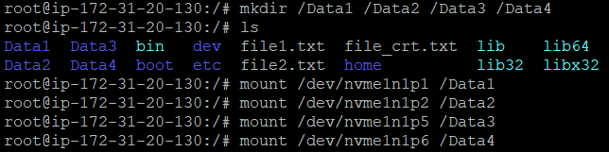

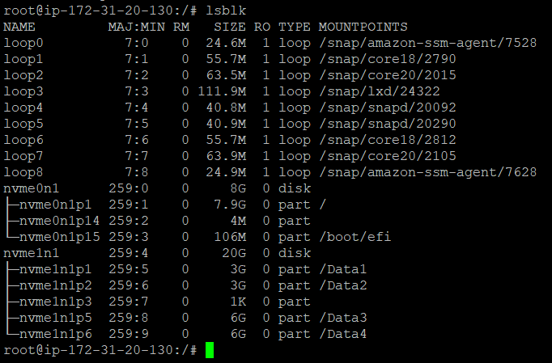

* Creating empty file inside each folders of size 2 GB, 2GB, 4 GB and 4 GB respectively  using  command -  **dd**

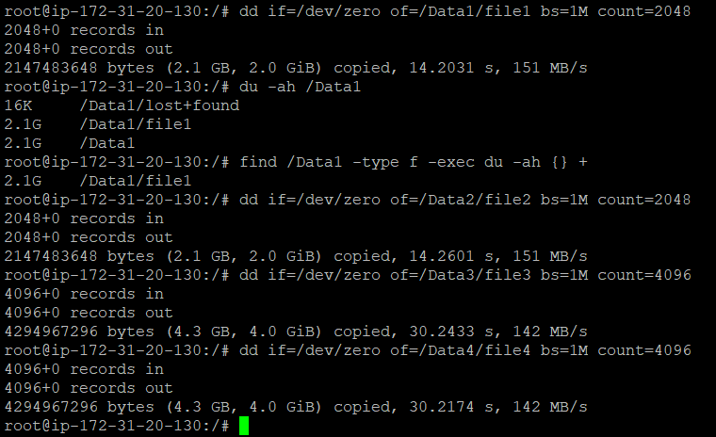

* Running the follwing command inside “/Data1” -  while(true); do sleep 5s; done

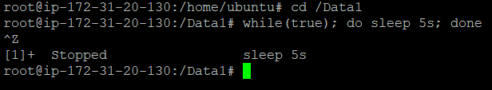

* To permanently mount the partitions post reboot I have too edit the **fstab** file so that it is always available post reboot.

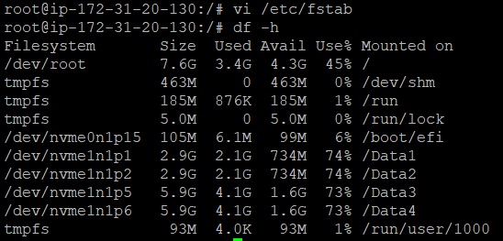

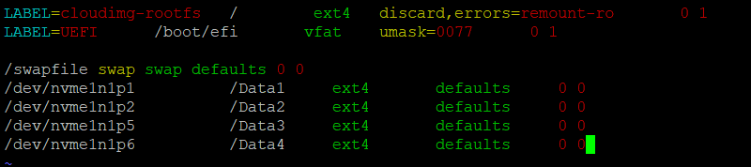

* Checking disk utilization of each mount point by using the **df** command.



* Unmounting all partitions from the folder using **umount** command.

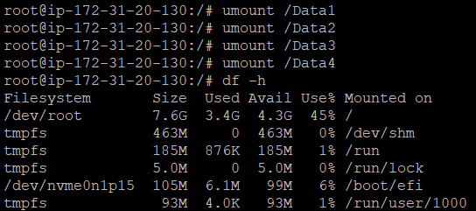

* This list of blocks show that the partitions are successfull unmounted.

